A Technical seminar report on

**INDOOR NAVIGATION**

Submitted in the partial fulfillment of the requirements for the award of the degree

**BACHELOR OF TECHNOLOGY**

IN

**COMPUTER SCIENCE AND ENGINEERING**

**Submitted by**

**P.NagaTejaswi**

**15071A0599**

# DEPARTMENT OF COMPUTER SCIENCE AND ENGINEERING

**VNR VIGNANA JYOTHI INSTITUTE OF ENGINEERING & TECHNOLOGY,**

**Bachupally, Nizampet (SO), Hyderabad – 500 090**

An Autonomous Institute, NAAC Accredited with A++ Grade NBA Accredited for CE, EEE, ME, ECE, CSE, EIE, IT B.Tech Courses

Approved by AICTE, New Delhi, Affiliated to JNTUH



**DEPARTMENT OF COMPUTER SCIENCE AND ENGINEERING**

**CERTIFICATE**

This is to certify that Technical Seminar Report entitled “**INDOOR NAVIGATION”** is a record of bonafide work carried out by **P.Naga Tejaswi (15071A099)** during the academic year 2018-19 in partial fulfilment of the award of the degree of Bachelor of Technology in Computer Science & Engineering by VNR Vignana Jyothi Institute of Engineering and Technology College, Hyderabad.

Coordinators:

Mrs.Somavarapu Jahnavi, Assistant Professor Mrs. B. V. Kiranmayee Mr. K.Bheema Lingappa, Assistant Professor Associate Professor

CSE Department Head of CSE Department

VNR VJIET. VNR VJIET.

**ACKNOWLEDGEMENT**

Firstly, I would like to express our immense gratitude towards our institution **VNR Vignana Jyothi Institute of Engineering and Technology** for providing us with opportunity of fulfilment of my cherished goal of becoming **BACHELOR OF TECHNOLOGY IN COMPUTER SCIENCE AND ENGINEERING.**

I am very thankful to our Principal**, Dr. C. D. Naidu** and our Head of Department, **Mrs. B. V. Kiranmayee,** for providing me an excellent academic atmosphere in the institution.

I extend my heartful thanks to the coordinators **Mrs. Jahnavi** and **Mr. Bimma Lingappa**

for their enthusiastic guidance to do the best.

Last but not least, our appreciable obligation goes to all the staff members of Computer Science and Engineering Department, parents and my fellow classmates who directly or indirectly helped us.

**P.Naga Tejaswi**

**15071A0599**

LIST OF CHAPTERS

**CHAPTERS PAGE NO**

# INTODUCTION 1

1.1. Introduction 4

1.2 . Indoor positioning as a physical context 2

1. **DESCRIPTION 3**

2.1. Description 4

**3. WORKING 7**

3.1. Geodata modelling 4

* 1. Shortest path algorithm 4

3.3. Map-matching for pedestrian navigation 3

3.3.1. Point-to-point method 4

3.3.2. Point-to-curve(link) method 4

3.4. Initial phase 8

3.4.1. Select the correct link 3

3.4.2. The same floor condition 4

3.4.3. The sufficient proximity condition 4

3.4.4. The optimal location condition

3.5. Weighting system 7

3.5.1. Weight for proximity to network link

3.5.2. Weight for the similarity in orientation

3.4.3. Total weight

3.6. Vertical movement,changing floors 4

3.7. System tests

3.7.1. The pedestrian navigation module

3.7.2. Test scenario

3.8. Performance Analysis

3.8.1. Evaluation of Map-matching

3.8.2. Graphic analysis of map-matching

3.8.3. Performance of navigation

**4. APPLICATIONS 4**

4.1. Applications 3

4.2. Advantages 4

4.3. Disadvantages 3

**5. CONCLUSION 4**

**6. REFERENCES 3**

**LIST OF FIGURES**

|  |  |  |
| --- | --- | --- |
| **S.NO** | **NAME** | **PAGE NO** |
| Fig 1 | General concept for indoor navigation | 01 |
| Fig 2 | Link/node view of the campus EPFL | 01 |
| Fig 3 | 3D view of the links between floors | 01 |
| Fig 4 | Nodal matching in case of vertical movements | 03 |
| Fig 5 | View of the PNM used for the tests |  |
| Fig 6 | Typical situation for indoor navigation |  |
| Fig 7 | Data flow for the navigation test. |  |
| Fig 8 | A raw pedestrian’s trajectory without calibration of the misalignment and step model. |  |
| Fig 9 | Trajectory passing through a corridor (raw positions in red and matched points in blue) |  |
| Fig 10 | Trajectory passing through a corridor and changing the floor using an elevator |  |
| Fig 11 | Changing the floor using a staircase *(*raw positions in red and matched points in blue). |  |
|  |  |  |
|  |  |  |
|  |  |  |
|  |  |  |
|  |  |  |
|  |  |  |
|  |  |  |
|  |  |  |

**ABSTRACT**

The indoor navigation is a system which is used to locate the exact locations inside a campus. This paper discusses about the navigation technology which uses the data stored in the active database of a University to locate the places which are requested, this system does not use the GPS (Global Positioning System) and any other Internettechnologies. Both the 2-D (2-dimensional) and the 3-D (3-dimensional) navigations are possible in this system. The 2-dimensional navigation system uses the floor map of the campus and it directs the user with help of a route and in addition, the system guides with a path assistance mechanism. The graphical representations of the University buildings are used for 3-dimensional navigation which offers street view of the campus for the user to locate places.

**CHAPTER-1**

**INTRODUCTION**

# 1.1 Introduction

We present the development and the implementation of algorithms to access map databases by a user equipped with a pedestrian navigation system.

The first step consists in building a 3D topological model specifically designed for the localisation process. Rooms, corridors, stairs and halls must be assembled in order to provide a model for route guidance.

The link/node view of a network has a significant advantage in supporting navigation, since a path through a network is readily expressed as a series of decisions at nodes. The classical methods developed to find optimum paths through networks, such as the shortest path algorithm (Dijkstra), are based on link/node structures.

The second step consists in the development of map-matching routines. The pedestrian navigation system provides the user’s position, which is combined with the link/node model. A dedicated map-matching algorithm processes the combination of the position data with the map database.

The present development of an indoor navigation system allows the evaluation of navigation algorithms in a post-processing mode. Several indoor trajectories were performed to analyse the system..

**1.2 Indoor positioning as a physical context**

A key component of physical context here is user location. As GPS-based applications such as Google Maps have become ubiquitous, their popularity has bred other services that not only utilize location data directly, but also adapt themselves as per a user’s real-time positioning. For instance, applications now learn about user preferences for cab and home delivery services based on location, thereby enabling personalized services based on whether a user is at home, work or anywhere else. However, such applications only provide information about places that are identifiable on geographical maps.

To provide truly immersive and contextual experiences, it is thus necessary to get a granular understanding of the indoor spaces a user interacts with. Such spaces are characterized by a much higher diversity of semantic interpretations. Unlike geographical places that are defined by standardized notions of a street, junction, building etc., indoor spaces differ in the sense of their utility. For instance, the structure of a workplace is completely different from that of a house or a supermarket. So, it is essential for indoor positioning solutions to adapt to all varying notions of indoor spaces.

# CHAPTER-2

# DESCRIPTION

# Description

The development of indoor navigation applications is growing, and one must use existing digital map databases for localisation and guidance procedures. Due to the specific design of indoor maps, special algorithms must be developed to combine different sources of data within the navigation process.

The objective of this research is to define and to implement a dedicated data model for indoor applications. Based on this specific model, route guidance and navigation algorithms can be integrated in order to develop applications with particular requirements. Navigation of physicallychallenged people is one example where the database must fit with specific algorithms in order to deliver reliable navigation information to the user [Gilliéron, 2003].

***User***

Localisation

Map -

Matching

Pedestrian

Navigation System

Position

Integrity

Route

Guidance

Map

Database

Figure 1: General concept for indoor navigation

The final objective of the navigation system is to develop an integrated system which provides support when defining the travel as well as guidance to the selected destination. Such procedures are well implemented in car navigation systems based on road databases. For indoor navigation, the concept of “route” guidance must be reconsidered for several reasons: specific design of map database, style of human displacement and particular needs for users.

# 

# CHAPTER-3

# WORKING

**3.1**  **Geodata modelling**

Most of the databases for the maintenance of buildings are based on a 2D graphical representation inherited from design plans. The content of such a database is composed of many objects (corridor, room, elevator,…) which are useful for positioning purposes. All these objects are designed with a geometric view and are composed of shapes, arcs and circles. However, to propose a navigation view of buildings, a deeper knowledge of the map objects is required in addition to more information about their topological relationships.

Car navigation systems are based on a link/node view of the street network, which has significant advantages in supporting navigation. The algorithms developed to find optimal paths though networks, such as the shortest path, are based on link/node structure [Büchel, 2004].

The implementation of a link/node model is envisaged for the campus of the EPFL. A large number of buildings, rooms and corridors are transformed in a network representation of the campus. Graph theory defines an arc as a set of curves in the Euclidian plan (*R2*). An arc can be completely characterized by a finite sequence of points. A node is a point at which an arc terminates or begins or a point at which it is possible to move from one arc to another. A link is a linear element between two adjacent points. For our project this model is not completely appropriate since it represents the network in two dimensions only.

The main axes of the network are defined by the centerline of the corridors and the street axes between buildings. The doors are represented with their projection points on the centerline of the corridors. The projection point of each door is regarded as a node.

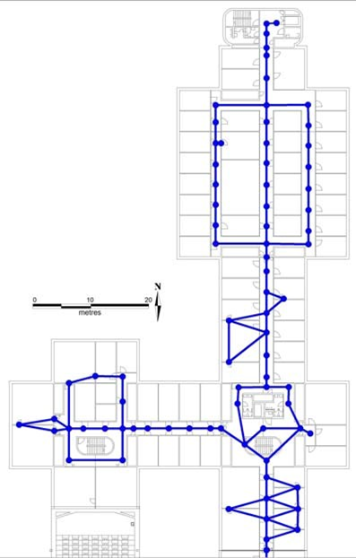

Figure 2: Link/node view of the campus EPFL

This link/node model lets the construction of a 2D network with the topological relationships between the main objects of one building’s floor. The connection between floors is possible by modeling staircases and elevators as vertical links. In order to realistically represent the buildings of the campus we have implemented the altitude as a third dimension. The third coordinate of each node is the altitude of the floor on which it is found.

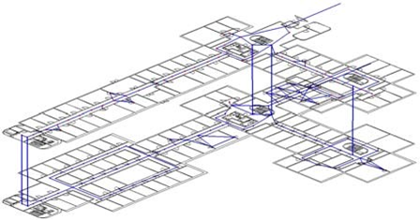

Figure 3: 3D view of the links between floors

The access doors of the elevators and the staircases are represented by vertically-connected nodes.

Each link has two nodes (start, end) which are georeferenced by a set of coordinates and altitude in a geodetic reference system. One link has attributes such as the type (horizontal, vertical), the length and information concerning the access privileges. The entrance to some buildings or rooms could be limited to a certain group of people. For this reason, this limitation must be taken into account in the navigation routines. For example, the computation of the best route has to output results which fit with the user’s profile (e.g., this person has the right to enter the building xy).

**3.2 Shortest path algorithm**

The link/node view of the network is designed for an optimal implementation of guidance algorithms. The main advantage of this model is the basic topological structure, which allows for a simple use of cost functions. Each link has a list of attributes used for the computation of the cost, which is mainly based on the time to travel to a link from start-node to endnode.

The implementation of a shortest path algorithm is simple when the cost function is defined for all links of the database. The length of a path is the sum of all individual costs of the links. The access restriction is given by a very high cost value. The cost for the vertical links (elevators, staircases) is given by a mean travel time (equ. 1). costi = *fi* (*l s a t*, , , ) *l* :*length of link i*

*s* :*speed*(*m*/ )*s*  (1)

*a* :*access rights t* :*type of person*

The computation of the best route is based on a Dijkstra’s algorithm which is specifically designed for a continuous and oriented graph. The algorithm has to estimate the shortest path between a start node and an end node given by a user who has a specific profile.

The best route computed by the system is used as input for the navigation process and for providing guidance information to the user.

**3.3 Map-matching for pedestrian navigation**

A navigation system must have the capability to provide a position even during bad reception of GPS signals. A dead reckoning (DR) process based on relative measurements of azimuth and distances gives the continuity of positioning. Without any positioning update, however, errors grow due to biases and drifts of the sensors. However, a map database can be used to update and verify the position given by the navigation system. This process of verification is called map-matching (MM).

In this section, it is assumed that a navigation system determines 3D positions (*Pt*) with a certain level of accuracy. The first approach of MM takes into account the coordinates of the local mapping system.

**3.3.1 Point-to-point method**

One way to proceed is to match *Pt* to the “closest” node in the network. The most natural way to proceed is to calculate the Euclidean distance [Bernstein, Kornhauser, 1996]. The Euclidean distance of two points *x* = (*x*1,...,*xn*) and *y* = (*y*1,...,*yn*) in Euclidean *n*-space is computed as:

)

(2

(

)

(

)

(

)

)

(

2

2

2

1

1

2

2

1

*n*

*n*

*n*

*i*

*i*

*i*

2

*x*

*y*

*x*

*y*

*y*

*x*

*y*

*x*

=

++

−

−

+

−

=

−

∑



In a point-to-point matching algorithm, one needs only to determine the distance between *Pt* and each point in the network sequentially, storing the closest point found along the way.

**3.3.2 Point-to-curve (link) method**

The next most natural way to proceed is to attempt to identify the link that is “closest” to *Pt*. The most common approach is to use the minimum distance from the point to the link. Equation (3) gives the distance from a point to a line.

*c*=(3)

)

(

(

)

(

)

)

(

)

(

)

(

2

2

2

1

2

2

1

12

21

2

2

1

2

1

2

*p*

*p*

*y*

*y*

*x*

*x*

*x*

*y*

*xy*

*xy*

*y*

*y*

*x*

*x*

−

+

−

−

+

+

−

−

where:

***c*** is the distance from *Pt* (*xp, yp*) to a line determined by two nodes (*1* and *2*)

*Pt*  and both nodes are presented with their coordinates.

Once we have the points of the pedestrian's trajectory, we can associate them with the network model. The MM algorithm uses a combination of Point-to-Point and Point-to-Curve matching. It is also based on the calculation of the weight of each candidate link. As input to our MM process we have two data sources: the map database (links, nodes) and the list of positions recorded by the navigation system.

**3.4 Initial phase**

The nodal matching is the most appropriate way to initiate the MM process. The first step must be carried out carefully and reliably, as there could be many potential candidate links [Quddus et al., 2003].

The MM algorithm starts initially with a point-to-point matching. Each node can be considered as a start or end of one or several links, each of which in turn could represent the pedestrian's course.

**3.4.1 Select the correct link***.*

There are several conditions that must be met in order for a link to be considered as a probable link:

to be on the same floor, as the measured point (*Pt*) is;

to be sufficiently close to the measured point (*Pt*);

to be located optimally with respect to the measured point (*Pt*).

Each of these conditions will be described in detail below.

**3.4.2 The same floor condition**

As a first step the difference between the altitudes must be considered. The accuracy of measured altitude has been investigated performing different trajectories and a tolerance of 50cm has been determined. If the altitude of the link is within this tolerance, then the algorithm considers that *Pt* and the link lay in the same floor. If the link does not fulfil this condition, the algorithm does not check for the other two conditions and passes automatically to the next link from the database. Thus the algorithm will work with links from one floor only.

**3.4.3 The sufficient proximity condition**

The principal criterion for the fulfilment of this condition is the perpendicular distance from *Pt* to the link. If this distance is smaller or equal to a previously defined tolerance, the algorithm considers that the link is within sufficient proximity to (*Pt*).

**3.4.4 The optimal location condition**

The sufficient proximity of the measured point (*Pt*) to the link is not enough to consider the link as probable. The algorithm checks if the projection of *Pt* on that link is between both determinative points.

Any link that fulfils the three conditions described above is considered as a probable link. The next step of the algorithm is to qualify each of the probable (candidate) links in order to choose the correct one.

**3.5 Weighting system**

A weighting system is applied based on the various similarity criteria between the measured point and the network topology . The importance of each criterion can be adjusted after considering weight factors. In our MM algorithm we assign two weights - weight for proximity and weight

for similarity in orientation. The final decision is based on the total weight which is the sum of both weights.

**3..5.1 Weight for proximity to network link**

The principal criterion for the proximity of a point to a link is the perpendicular distance from the point to the link. As the perpendicular distance *c* decreases the proximity increases. Therefore the weighting score for proximity to network link is defined as:

*Ap*

*WSPD* = (4) *c*

Where:

*WS****PD*** is the weighting score for proximity to network link

*c* is the perpendicular distance from the point to the link

***A****P**> 0* is the weighting parameter that controls the value of *WSPD*.

**3.5.2 Weight for the similarity in orientation**

The determination of the weight *WS****H*** is based on the difference between two azimuths. The first azimuth is given by the selected link and the second is formed by the last two measured points. The difference between each pair of azimuths will be a good indicator of the similarity in orientation. The link with the smallest difference in the orientation will obtain the biggest weighting score.

*WSH* = *AH* ⋅*k* (5)

where:

*WS****H*** is the weighting score for similarity in orientation

*AH* is a weighting parameter that must be positive and bigger then *AP*. *k* = │cos(*∆β*)│

*∆β* is the angle between both azimuths

**3.5.3 Total weight**

The total weighting score can then be obtained by summing up the individual scores. By selecting different values for the weighting parameters, the weight assigned can be carefully controlled. [Quddus et al., 2003]. The value of total weight is then calculated for all the candidate links. The link that provides the highest score is taken as the correct link for that measured point.

**3.5 Vertical movement, changing floors**

An essential part of the algorithm is the detection of a vertical movement. This is why for each pair of consequent steps the horizontal length and the elevation is calculated. The decrease of the horizontal length of the steps could be a sign for a vertical movement (e.g. using staircases). Moreover, in an elevator a pedestrian does not normally walk, so the horizontal length of his step is assumed to be zero. We assume that with a normal straight gait the length of the human's stride is approximately 70cm. If the length of the step is lower than 45cm the algorithm performs a nodal matching.

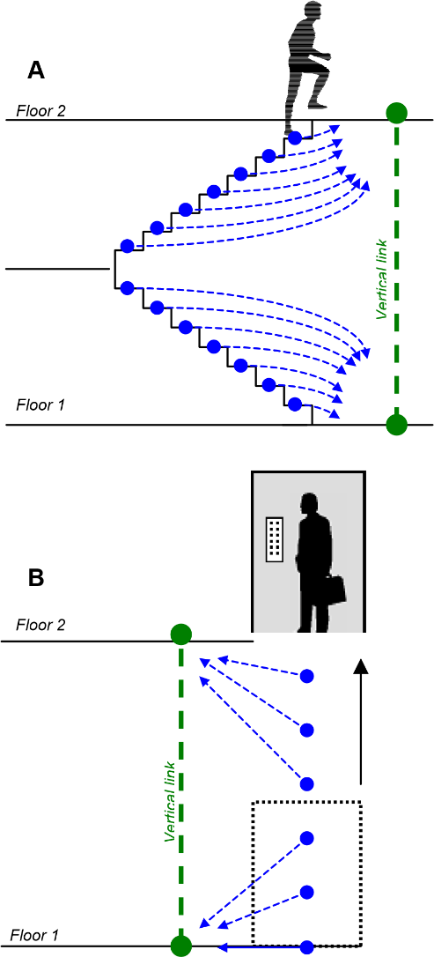

Figure 4: Nodal matching in case of vertical movements

To change floors the pedestrian can use an elevator or staircases. In both cases the horizontal length of the step is lower then the defined limit of 45cm. As

well we need to check the elevation between the steps. A limit of 15cm is assumed, which is almost the height of a single stair. If the elevation is higher than this limit the algorithm considers it as a vertical movement and performs a nodal matching (Fig.4-A). The steps of the vertical movement will be matched only to nodes of the vertical link.

For the elevator we have assumed a mean speed of 1m/s. Considering the parameters of the navigation system during the vertical movement the pedestrian's position will be registered each 50cm, during which there are no steps performed (Fig.4-B).

During a vertical movement the algorithm performs a nodal matching considering the vertical nodes only. The vertical nodes are situated relatively far from each other. This fact allows to increase the horizontal search limit for the matching process. This is very useful when raw points in a staircase have to be matched.

**5. System tests**

This project combines a specific database model with navigation algorithms, which have to be evaluated separately from the positioning system itself. The following tests were established in order to record several trajectories with a pedestrian navigation system and to apply the map-matching procedures in a post-processing mode.

**The pedestrian navigation module (PNM)**

For dead reckoning with vehicles, the traditional approach consists in using a triad of accelerometers and gyroscopes generating signals, which are integrated to obtain the relative displacement. However, the classic GPS/IMU approach used for vehicle navigation does not adapt well to pedestrian navigation. This concept is difficult to implement with a low-cost system. The principal reason is that the sensors’ noise blurs the signals that correspond to the displacement of a person. An approach by occurrence was developed, whereby the steps are detected, their type identified and their length estimated based upon a subset of sensors as well as physiological and biomechanical parameters of the walk.

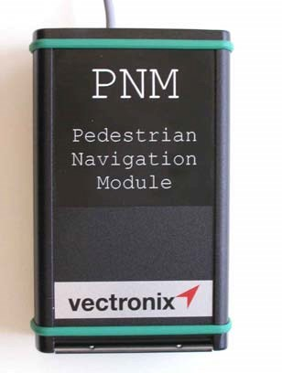

Figure 5: View of the PNM used for the tests.

The Geodetic Engineering Laboratory of EPFL has been involved in the development of the Pedestrian Navigation Module (PNM) fulfilling these requirements. This project results from a close collaboration between the EPFL and Vectronix AG.

The PNM consists of a GPS receiver, a digital magnetic compass, a gyroscope, a barometer and embedded DR algorithms. All the sensors are installed in a small box. The weight of the device is inferior to 400 grams and it functions optimally clipped at the belt. Hence, it can be worn without discomfort (Fig. 5).

The system output positions in the standard exchange format NMEA (National Marine Electronics Association), which is compatible with most GIS and navigation software. The output rate is variable with the dynamic of walk, but is between 1 and 2 Hz in most of the circumstances.

Using GPS data provides an absolute positioning when the user is outdoors. This condition is required for the autonomous calibration process of the step model and for the determination of the misalignment of the system with respect to the line of sight of the person. In the future, this procedure will be based on map-matching when no GPS signals, but digital georeferenced maps are available.

**Test scenario**

The main objective of this test is the evaluation of map-matching algorithms based on the measurements of real trajectories with the PNM. This test has been carried out on the campus at the EPFL.

The following objectives were defined for this experiment:

* to practice pedestrian navigation in typical indoor environment (staircases, doors, elevators,…); - to collect raw data of several trajectories with the PNM;
* to analyse real trajectories with the content of the map database;
* to determine the calibration parameters of the navigation instrument;
* to process trajectories data with mapmatching algorithms;
* to evaluate the navigation performance in specific situations;

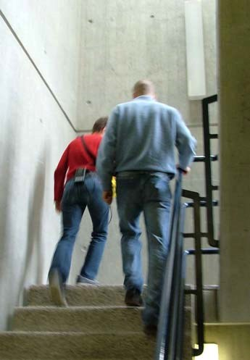

Placement of the PNM

Figure 6: Typical situation for indoor navigation

The present version of the indoor navigation concept is based on components which work separately (Fig. 7). The PNM outputs real-time positions which are stored on a data logger (Pocket PC).

A post-processing program enables the comparison of the recorded trajectories with the content of the map database. The calibration parameters

(misalignment, step model) are computed in order to rectify the raw trajectories. No information is sent back to the PNM. This option is envisaged in a future version once the map-matching takes place in real time.

Finally the MM process projects the positions on links of the network of the database. Each position is referred to a specific link.

Map database

Personal

Navigation

Module

Raw

Positions

Calibration

Corrected

trajectory

Map-Matching

Link/Node

Positions

Graphic Ouput

Plots for

analysis

Figure 7: Data flow for the navigation test.

The performance of the whole system should be evaluated with the following characteristics: the accuracy of the positioning, the continuity and availability of the service of navigation and the integrity risk. This concept of performance is well defined for safety critical application in air navigation and could be transposed in pedestrian navigation in order to inform the user about the status of the navigation service.

The **accuracy** is the position error that is experienced by a user within a certain probability. The **integrity** risk is defined as the probability that a user will experience a position error larger than a specified limit without an alarm.

The **availability** of the navigation service for the user is established by fulfilling simultaneously the accuracy and integrity requirements. The **continuity** of service requires that the navigation service is available for the user over a minimum time interval.

The results of this first test combining navigation data with a map database is presented as graphic plots (Fig. 9,10,11). This approach allows the interpretation of the quality of the navigation in typical indoor situations.

**6. Performance Analysis**

**Data analysis**

During the test the PNM system measured the coordinates at each step (*Pt*). Thus the trajectory is represented by a sequence of 3D points. Considering the characteristics of the PNM, when the user stops, a position fix is made twice per second. This attribute is applicable when the user is in an elevator or rotating around him/herself without 2D displacement.

**Calibration**

This first step of analysis focuses on the determination of the global parameters of calibration. The user started to walk from a room without any GPS signal. Therefore, no calibration of the misalignment and scale factor could be performed. The user only entered the position of the starting point in the system.

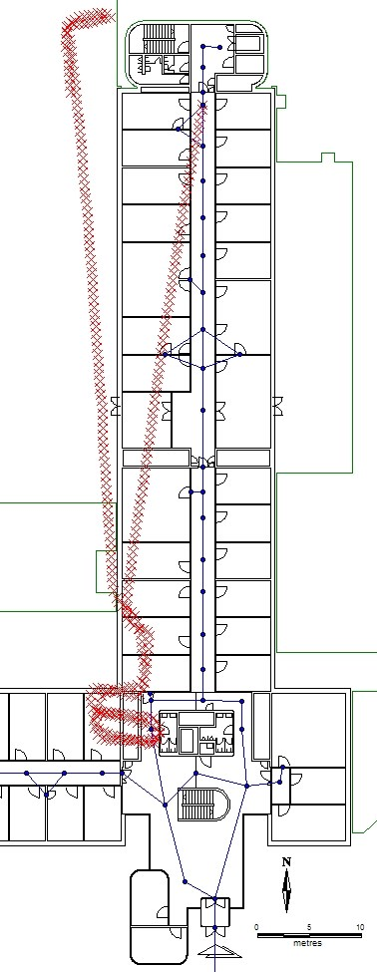

Figure 8: A raw pedestrian’s trajectory without calibration of the misalignment and step model.

After the walk, a raw trajectory was stored in the data logger and was available for the so-called postcalibration. The basic idea of this process is based on the comparison of the raw trajectory with the link/node view of the map database. This visual analysis is shown on figure 8, which combines raw positions (red crosses) and the navigation network. It is clearly visible that the measured trajectory is displaced by a rotation and by a scale factor.

The parameters of calibration are determined by a geometric transformation in order to adjust the raw trajectory to the link/node view. Specific points of adjustment are chosen in both views before processing the transformation. These pairs of points can be manually identified.

All nodes along a straight corridor are most suitable to perform the adjustment of measured coordinates. The raw trajectory which correspond to such a corridor can be easily discerned.

The calibration is a procedure that could be repeated if necessary, considering similar straight sections of the trajectory.

**Evaluation of Map-matching**

The indoor navigation system is based on the principle of dead reckoning. The positioning errors are not only random, but increase with time because of the accuracy of the sensors. Therefore there is a need to apply a MM algorithm. The main problems to solve are:

 to control the position of the user at regular time interval;

 to provide a recalibration of the navigation system.

The MM algorithm is performed during postprocessing of the positioning data which results from the transformation after the calibration. At each user’s step a pair of consecutive points is analysed. The azimuth, the horizontal distance and the elevation between both points are calculated.

The application of the “point-to-curve” matching method has shown very promising results. However, the most delicate part of the algorithm is the choice of the appropriate weighting parameters. They must be carefully estimated, in order to provide a correct association between the raw position of the user and the points in the database.

On the other hand, the implementation of vertical nodes is very useful for matching the user’s position during a vertical movement.

Finally, the MM algorithm has the capability to identify specific nodes on the network, such as a point of intersection of corridors where the user is turning. Therefore a rapid change in orientation could be detected automatically and the updated information could be provided for a recalibration of the navigation system.

**Graphic analysis of map-matching**

The following figures illustrate typical situations for indoor navigation: passing through a corridor (Fig.9), changing the floor using an elevator (Fig.10) and going up or downstairs (Fig.11). The final result of the MM algorithm is the positions of the matched points. They are calculated in consequence of a number of corrections (distance point-to-link, difference of the azimuth, etc.).

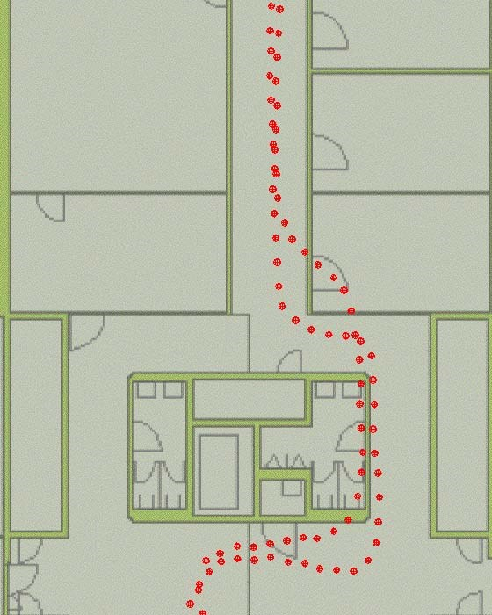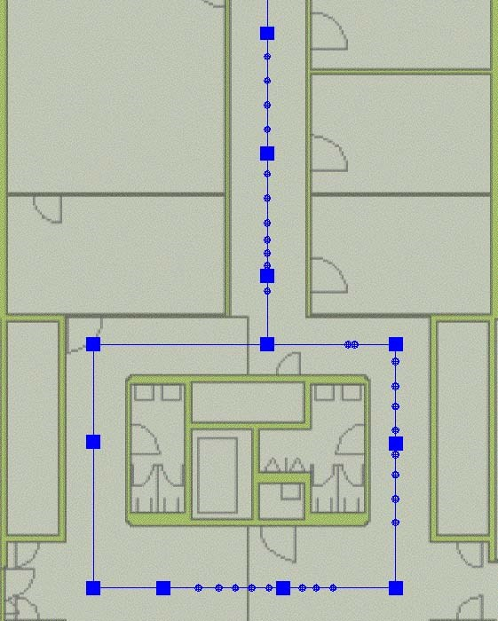

Figure 9: Trajectory passing through a corridor (raw positions in red and matched points in blue)

The bigger part of the points of the raw trajectory in the corridor fulfils the conditions of the MM algorithm. Their respective MM points are calculated with success. However there are raw points that do not fulfil all the conditions, such as those situated in the turns of the trajectory. Each of these points is considered by the MM algorithm as the beginning of a new trajectory. In this case a nodal matching is performed. Thus, most of the MM points at the turns are located on the nodes. By applying this technique the MM process runs continuously.

The same method is applied when the user changes the floor using an elevator (Fig.10). All the raw points registered during this vertical movement are matched to the closest vertical node. The MM process does not stop before getting into elevator or after leaving it.

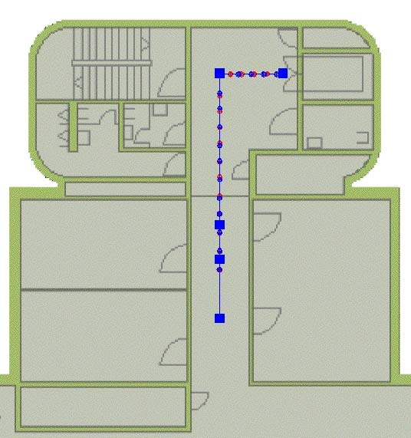

Figure 10: Trajectory passing through a corridor and changing the floor using an elevator.

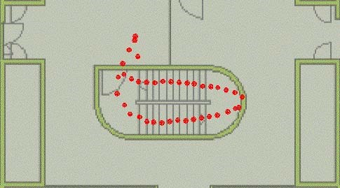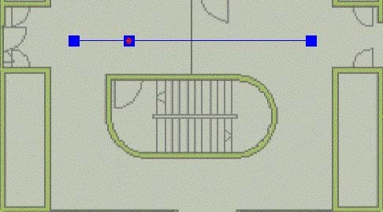

Figure11: Changing the floor using a staircase *(raw positions in red and matched points in blue*).

Whether using a staircase or an elevator, the MM process handles the vertical movement in the same way (Fig.11). All the raw points are matched to the closest vertical node. Here the increase in the horizontal search limit is most effective. Even the raw points in the middle of the staircase, which are further from the vertical node are truly matched.

**Performance of navigation**

The results of this test do not allow for a rigorous determination of the navigation performance. All parameters described in section 5 have to be estimated with statistical methods, which have not been implemented yet.

The evaluation of the positioning accuracy could be based on the comparison of the measured positions after calibration with the content of the map database. In this case, we assume that the user was walking in the middle of corridors, following the main nodes of the network. As shown in Figures 9 and 10, the measured trajectory always matches the spatial position of the corridor. There are no jumps in positions and the average distance to the middle of the corridor is acceptable.

The integrity is more difficult to evaluate in this first analysis of the performance. One relevant item is the absence of misinformation during the test. After the calibration process all positions were reliable. No system failure due to environmental effects (magnetic disturbance, pressure variation) was experienced. Under our testing conditions, the navigation system supplied continuous information during the entire test.

# CHAPTER-4

# APPLICATIONS

* 1. **Applications**

# Guide people inside a shopping mall (you've probably seen these large maps mounted inside malls which guide you towards stores, food courts & restrooms. Imagine being able to access them via your smartphone and dynamically categorize them based on your interest, search what you are looking for. All that is possible if you have indoor positioning available.

# Museum tours : Your phone can be your virtual guide that'll give you contextual information based on your location.

# Warehouses : Improved automation capabilities.

# Airport, Hospitals, Hotels : Benefits are similar to above applications.

# Guidance to visually impaired : With audible & sensory feedback, your mobile phone can help you navigate indoors, be it large locations like the examples above or even inside your house. The accuracy of some of these systems using WiFi for triangulation is of the order of a few square feet.

# 4.2 Advantages

**Easier for users -** Indoor wayfinding becomes even easier with an indoor positioning system as users don’t have to type in their current position when navigating from point A to point B. Likewise, they don’t have to worry about counting doors, turns, or the like as they can see their real time position on the map (blue dot) as they move through the building.

**Improved UX -** Another advantage of IPS is the improved user experience. Besides making it easier for users to navigate, indoor positioning system ensures a user experience à la Google Maps, which users already know and love.

**Insights -** With an indoor positioning system you also have the possibility of heat mapping, so you can see how people move around your venue. This allows you to gain important insights on what’s good about your layout and what could be improved to increase sales at merchandise stalls, minimize wait times at food and drink vendors, or differentiate stand pricing at conventions

**Location-based marketing -** The combination of indoor navigation and indoor positioning also gives you the benefits of location-based marketing. Not only does this allow you to create a more personalized experience (think of sending special offers when shoppers are stopping at the pasta aisle or use the information you have on stadium visitors, for instance from ticket sales, to send a personalized welcoming messages), it also allows you to turn your investment into a lucrative business. By offering exhibitors, sponsors, or partners the option to buy marketing opportunities through push notifications, you’ll make your venue more interesting and potentially increase your ROI.

# 

# 4.3 Disadvantages

**An investment -** Speaking of ROI, there’s no doubt that indoor positioning is an investment. First off all, it’s a subscription and not a one-off payment, and second of all, it’s time consuming to set up. Setting up an indoor positioning system usually means deploying Bluetooth beacons, but it also means fingerprinting your venue, which is a time consuming task. Just to give you an idea of the task, buildings need at least 1 beacon per 200 m2 in average depending on the physics of the building as well as the accuracy needed.

**Finding the right provider** - Indoor positioning is expensive so it’s important to find the provider that matches your needs the best. How accurate do you need the positioning to be? It’s a given you want a reliable solution, but if you’re guiding travelers around your airport, you don’t need the same accuracy as if you’re guiding people to the right book at a library or shoppers to the item on the shelf. You also need to think about the power consumption or if you need additional features like analytics, offline positioning, etc.

**Bad positioning is worse than no indoor positioning** - The indoor position market is a confusing market with a lot of different players who are all claiming to provide accurate indoor positioning, but you shouldn’t just take their word for it. Our advice is to go with a provider that has a good track record, because bad positioning is actually worse than no positioning. Say for instance you’re trying to find a meeting room in a large office building. A good indoor positioning system will show you your exact position, so you can easily navigate to the room, but a bad positioning system may think you’re on the 2nd floor instead for the 3rd. This means that the wayfinding solution will provide you with the wrong directions and you’ll be late for your meeting.

# CHAPTER-5

# CONCLUSION

The objective of this research was the implementation of a specific data model and navigations routines for indoor applications. The development of a map database for the campus of the EPFL has proven that a link/node model is well adapted for navigation purposes.

The use of map-matching algorithms in order to enhance the navigation performance is absolutely necessary for indoor applications. The association between the estimated position given by the system and the location on the map database provided improved information to the user.

The first test of indoor navigation shows very promising results and confirms the potential of map matching as a robust positioning method. The next challenge of this research will be to develop an integrated system which combines the navigation system itself with an intelligent map database.

**CHAPTER-6**

**REFERENCES**

**References**

[1] [Bernstein, 1996] Bernstein D., Kornhauser A. An Introduction to Map Matching for Personal Navigation Assistants**,** New Jersey TIDE Center, New Jersey Institute of Technology

[2] [Büchel, 2004] Büchel D., Développement d’une solution de navigation robuste pour l’environnement construit, diploma thesis, EPFL

[3] [Gilliéron, 2003] Gilliéron PY., Merminod B., Personal Navigation System for Indoor Applications, World Congress IAIN, Berlin

[4] [Greenfeld, 2002] Greenfeld J.S. Matching GPS observations to locations on a digital map**,** In proceedings of the 81th Annual Meeting of the Transportation Research Board, Washington D.C.

[5] [Ladetto, 2002] Ladetto Q., Merminod B., In Step with INS – Navigation for the Blind, Tracking Emergency Crews, GPS World 10/02

[6] [Ladetto, 2002] Ladetto Q., Merminod B., Digital Magnetic Compass and Gyroscope Integration for Pedestrian Navigation, 9th St-Petersburg International Conference on Integrated Navigation Systems